Document – link to code Repo
- Official CKA Exam Blueprint:
GitHub - cncf/curriculum: 📚Open Source Curriculum for CNCF Certification Courses
- Our CKA GitHub Repo link:
GitHub - zealvora/certified-kubernetes-administrator

Overview of container orchestration
Container orchestration is all about managing the life cycles of containers, especially in large, dynamic environments.
Eg: Let’s assume Let’s 2 VMs are having one web server and one app server up and running on each. Due to some issue one of it gets down. But our requirement is always to maintain 2 containers of web server and 2 container of apps server. Due to some reason the downed container are not getting restarting in that case the script should automatically create the another container in VM3.
The above scenario can be achieved through orchestration.
Container orchestration can perform lot of tasks:
- Provisioning and deployments of containers
- Scaling up or removing containers to spread application load evenly.
- Movement of containers from one host to another if there is a shortage of resources
- Load balancing of service discovery between containers
- Health monitoring of containers and hosts.
Eg2: minimum of 2 web-servers should be running all the time.
If we have 2 VMs, but the 2 containers are running on the same server First there would be a resource related issues if the production traffic increases and second there is no high availability.
Container orchestration solutions:
- Docker swarm
- Kubernetes
- Apache Mesos
- AWS ECS
- EKS etc.,
Introduction to Kubernetes
Architecture of K8s:
Usually Kubernetes is having Master and along with worker nodes. When any user deploys anything Master will receive the task and it will give it to worker nodes. The user will send the command to master via API,CLI and GUI.
Installation options:
We can manage K8s multiple ways:
- Use the managed Kubernetes service
- Use Minikube
- Install & configure Kubernetes manually (Hard way)
Here we are using Managed kubernetes service for that we are using digital ocean cloud provider. It’s the only user providing free managed K8s but anyway we will get charged for nodes using in hourly basis.
Create a Digital ocean account and follow the below steps to install the cluster.
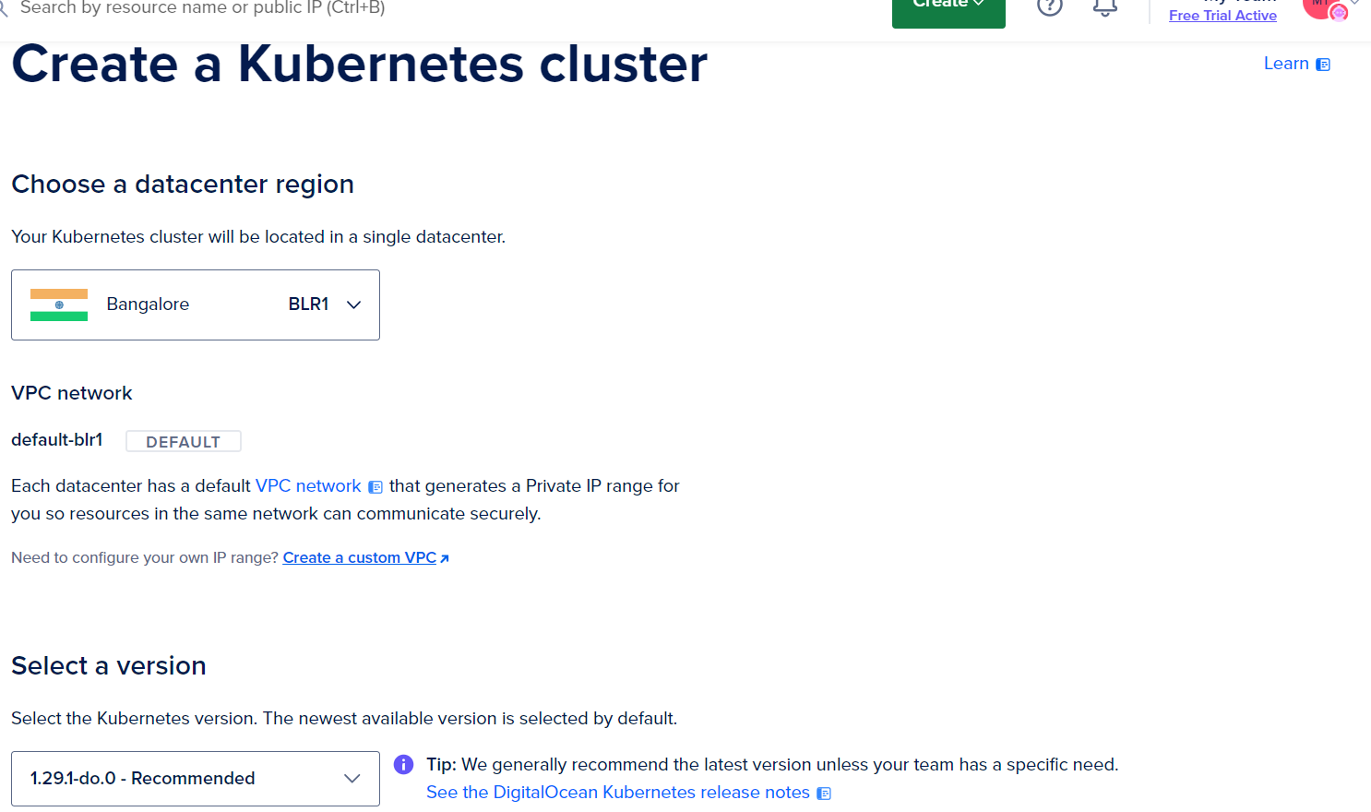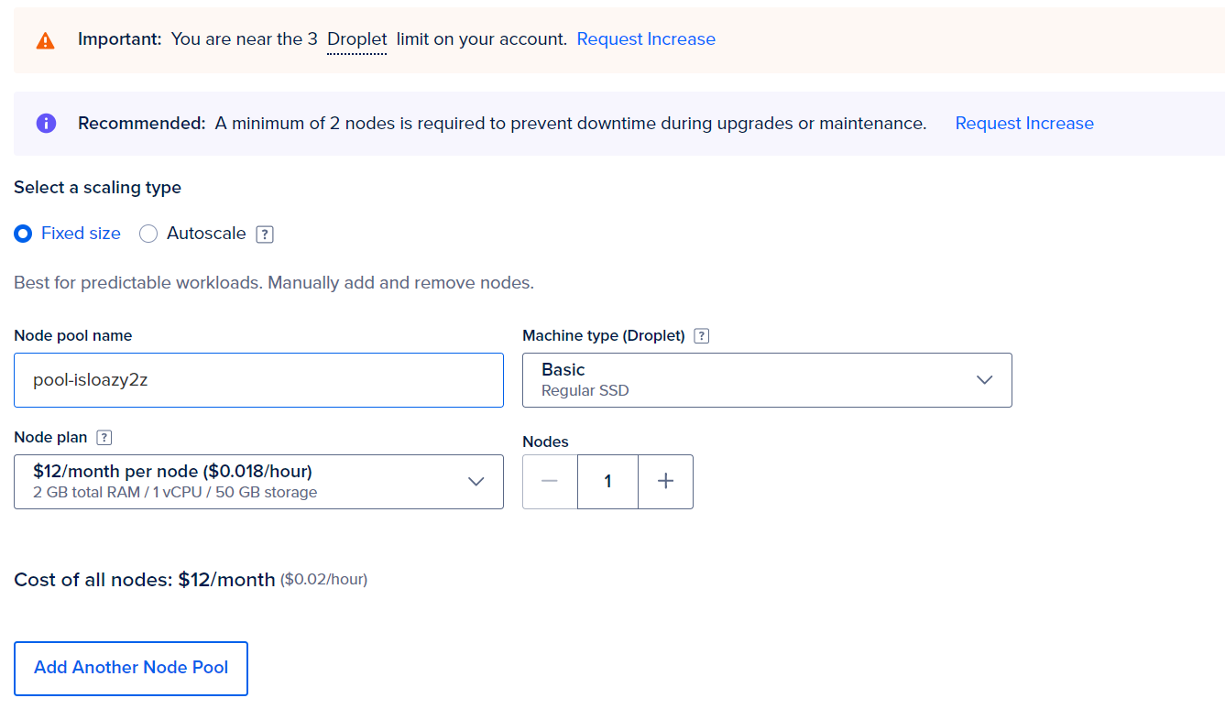
Before click on submit rename the node name and cluster name.
After creating it, you need to download the config file. It will be having link to access the cluster,user name and the authentication token.
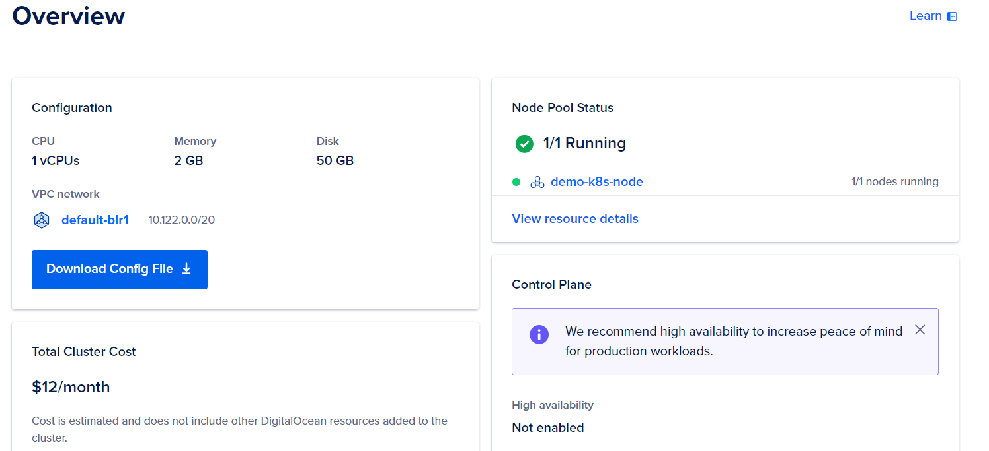
You can get the config file here.
After downloading the file. Go to Kubernetes site Install Tools | Kubernetes click on windows. From there we will download the Kubernetes app https://dl.k8s.io/release/v1.29.1/bin/windows/amd64/kubectl.exe.
Here we won’t follow the kuberenetes documentation from the site.
We will use the different approach.
If we paste the above link it will download the .exe file automatically after downloading. We will go to C drive we will create a folder Binaries and we will copy it. After copying the .exe file we will collect the path of the .exe file and we will set in env variable for that we will click on This PC properties-> Advanced system settings->Environment variables-> will click on ‘path’-> click on ‘new’-> paste the path and click on ‘ok’.
Now the downloaded config file we will copy and paste it in binaries folder. After doing this close the cmd and reopen again and run kubectl or kubectl get pods command.
Understanding pods:-
Pods are like containers the pod will encapsulate the container, each pod can have single container with its supported files or multiple containers with supported files. The suggestable way is using one container per pod.
Running a pod is almost same like a container
Kubectl run mywebserver image=nginx
By running above command, It will download and run container inside the pod.
To list the pods.
Kubectl get pods
To login into a pod we run
Kubectl exec -it mywebserver – bash
Here there is a space between - - and bash.
This - - separates the argument. With the help of - - ls -l / we can check the what’s inside the pod by running.
Kubectl exec -it mywebserver - - ls -l /
To delete the pod.
Kubectl delete pod mysebserver

Overview of K8s Objects
K8s objects is basically a record of intent that you pass on to the K8s cluster.
Once you create the object, the K8s system will constantly work to ensure that object exists that it can be pod,namespace,deployment and so on.
There are various ways in which we can configure the K8s objects.
- First approach is through the kubectl commands.
- Second approach is through configurations file written in YAML.
Benefits of Config file:
- Integrates well with the change review processes.
- Provides the source of record on what is live within the K8s cluster.
- Easier to troubleshoot changes with version control.
K8s- Before we Drive
Before we start full fledged deep drive into k8s, understanding the architecture is beneficial.
ETCD, API server, Scheduler, Controller manager, Cloud Controller Manager.
Kubernetes Master components:
K8s Master consist of five major componenets.
Component Name | Description
Kube-apiserver | Component on the master that exposes the K8s API.(Through this Master will pass the commands to worker nodes)
Kube-scheduler | Component on the master that watches newly created pods that have no node assigned, and selects a node for them to run on.
Etcd | Key value store used as K8s backing store for all cluster data.
Kube-controller-manager | Responsible for controlling various aspects, including:  Node controllers: Responsible when node goes down. Replication controllers, endpoint controllers, Service account & Token controllers
Cloud-controller-manager | Runs controllers that interact with the underlying cloud providers

K8s Node Components:- Node component runs on every worker node of the K8s cluster.
K8s worker node consists of two major components:
Component Name | Description
Kubelet | An agent that runs on each nodes in the cluster. It makes sure that containers are running in a pod.
Kube-proxy | Acts as a network proxy which maintains rules on the host and performing connection forwarding.
Container Runtime | Software which is responsible for running containers. Supported Runtimes: docker, containerd, rktlet and others

Etcd:- Etcd is used store the configuration data.
We know in linux /etc directory we have all configurations are stored.
Etcd also same but in an addition of d which is for distributed.
Etcd is a distributed reliable key-value store.
Etcd reliably stores the config data of the K8s cluster, representing the state of the cluster (what nodes exist in the cluster, what pods should be running, which nodes they are running on, and a whole lot more) at any given point of time.
Imp Pointers:
- A k8s cluster stores all its data in etcd.
- Anything that you read while running kubectl get pods is stored in etcd.
- Any node crashing or process dying causes values in etcd to be changed.
- Whenver you create something with kubectl create / kubectl run will create an entry in the etcd.
Kube-apiserver
API server acts as a gateway to the K8s cluster.
When you interact with your K8s cluster using the kubectl CLI, you are actually communicating with the master API server component.
The API server is the only k8s component that connect to etcd; all the other components must go through the API server to work with the cluster state.
The API Server is also responsible for the authentication and authorization mechanism. All API clients should be authenticated in order to interact with the API server.
Flow Diagram:-
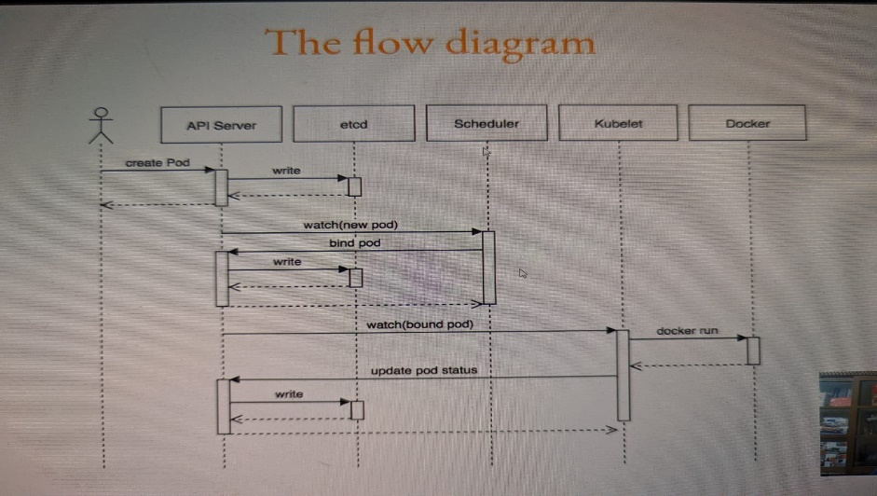
- Kubectl writes to the API server (kubectl run mywebserver –image=nginx)
- API server will authenticate and authorize. Upon validation, it will write it to etcd.
- Upon write to etcd, API server will invoke the scheduler.
- Scheduler decides which node the pod should run and return data to API server. API will in-turn write it back to etcd.
- API server will invoke the kubelet in the node decided by the scheduler.
- Kubelet communicates to the docker daemon via docker socket to create the container.
- Kubelet will update the status of the POD back to the API server.
- API server will write the status details back to etcd.
Introduction to API (Application programming Interface)
Watch this video to know in depth about API. Good one.
K8s API Primitives
Run below command to know more about API and command shortcuts.
Kubectl delete pod mysebserver
If we observer the previous video “Introduction to API” it was describing API version is version1 and kind is pod. The same attributes will be used in YAML script for configuration.
Levels | Description
Alpha Level | - Version names contains alpha  - Example:v1alpha  - May be buggy  - Enabling the feature may expose bugs  - Disabled by default
Beta Level | - The version names contain beta (e.g. v2beta3).  - Code is well tested. Enabling the feature is considered safe. Enabled by default.  Recommended for only non-business-critical uses because of potential for incompatible changes in subsequent releases.
Stable Level | - The version name is vX where X is an integer.  Eg: v1  Recommended to use in PROD envs.
Creating first POD configuration in YAML
There are various ways in which we can configure the K8s object.
- First approach is through the kubectl commands.
- Second approach is through configuration file written in YAML.
Understanding important fields
Key | Description
apiVersion | Version of API
Kind | Kind of object you want to create
Metadata name | Name of object that uniquely identifies it
Spec | Desired state of the object
To see how to write effectively, we have to go to k8s documentation abut pods.
Kubernetes API Reference Docs
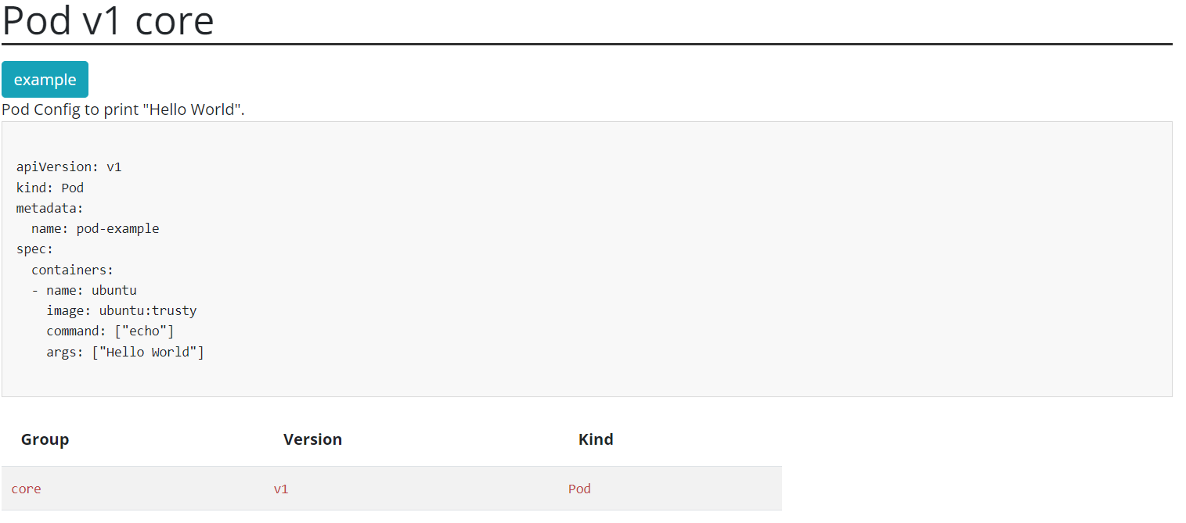
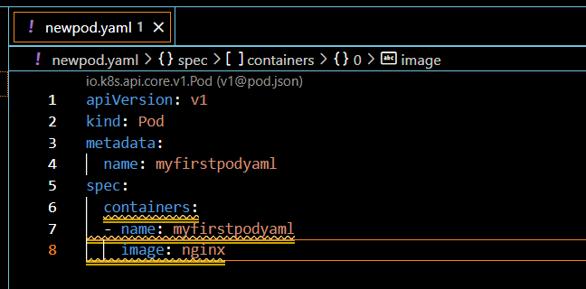
The above config script will help you to create a new pod.
After writing run
kubectl apply -f newpod.yaml
Working with multi container pods
Dealing with tightly coupled application:
Containers within a pod share an IP address and port space, and can find each other via localhost.
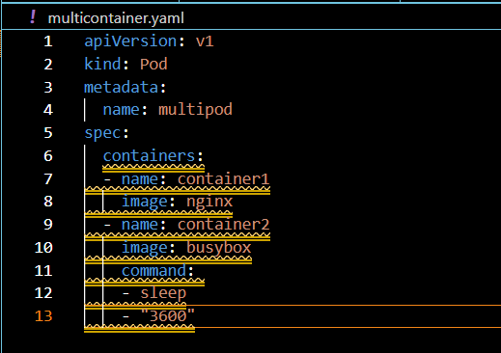
After writing the script run the below command
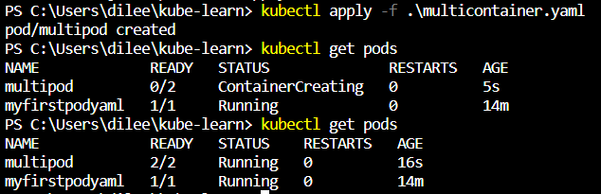
To check the pods in details run
kubectl describe pod multicontainer.yaml
to jump into container1 and container2. We need to use below commands.
Container1 for nginx
Kubectl exec -it multipod -c container1 -- bash
Container2 for busybox
Kubectl exec -it multipod -c container2 sh
Kube-scheduler
It watches for the newly created pods that have no node assigned, and selects a node for them to run on.
Eg: Let’s assume we have 3 servers 1 is speed,2 is slow and small and 3 is mediocre. Now user wants to run it in fastest server. So Kube-scheduler will decide this it will analyse and give reply to kube api server to take the 1st server which is fastest. Now API server will communicate with kubelet to run the pod on that server.
There are several factors which are taken into consideration before a pod is scheduled to a node.Some of these includes:
- Resource requirements
- Hardware/Software policy constraints
- Affinity & Anti-Affinity
- Data locality
Dockerfile CMD vs ENTRYPOINT
ENTRYPOINT:-
The best use of ENTRYPOINT is to set the image’s main command
ENTRYPOINT doesn’t allow you to override the command.
It’s important to understand diff between CMD and ENTRYPOINT.
If you specify CMD the whatever the command operative you specify it will be overwritten while executing the command.
Eg: If you specify CMD [“sh”] in Dockerfile and save it while running the container of that image it can be overwritten.
Docker container run -dt –name container1 image1 ping -c 10 google.com
The sh operator will be overwritten by ping -c 10 google.com
But If you use ENTRYPOINT it won’t get overwrite it will append to the command.
ENTRYPOINT [“/bin/ping”]
Docker container run -dt –name conaginer2 image2 -c 10 google.com
After appending it will look like this /bin/ping -c 10 google.com
Understanding commands and arguments
In previous video we discussed the diff between CMD and ENTRYPOINT in Dcokerfile. We can also refer them as Image command and Image Entrypoint.
In K8s, We can override the default entrypoint and CMD with command and args field.
Dockerfile vs K8s manifest Perspective:-
Docker Field Name | K8s Field name | Description
ENTRYPOINT | Command | Command that will be run by container
CMD | Args | Argument passed to the container
If you run docker run -d –name busybox busybox It will not run it will stop. Because we haven’t mentioned TTY. Now If we run docker run -d –name busybox busybox sleep3600 the container will run.
The same thing for K8s as well. We need to specify that.
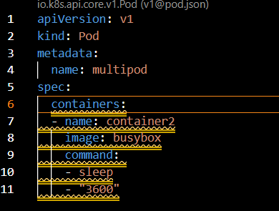
Another way to specify is
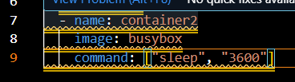
Another way
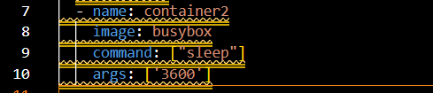
Another way
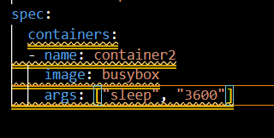
CLI Documentation for K8s resources
Accessing documentation through CLI. This can be achieved through kubectl explain command.
Eg:
- kubectl explain pod
- kubectl explain pod.spec
- kubectl explain pod.spec.containers
Dockerfile- EXPOSE instruction
The EXPOSE instruction informs Docker that the container listens on the specified network ports at runtime.
The EXPOSE instructions does not actually publish the port.
It functions as a type of documentation between the person who builds the image and the person who runs the container, about which ports are intended to be published.
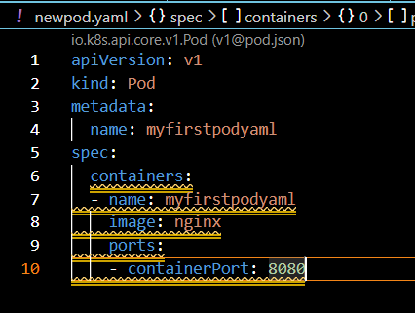
Generating Pod Manifests via CLI
kubectl run nginx-port –image=nginx –port=80
How to generate a Manifest file that is nothing but generating yaml file?
kubectl run nginx –image=nginx –port=80 –dry-run=client -o yaml
